1 -

<https://www.scanstore.com/Scanners/Compare_Document_Scanners.asp?selADF=>

ON&selColor=ON&selFlatbed=ON&selDuplex=ON&selMFeed=

ON&selMac=OFF&tMinPrice=4000&tMaxPrice=7000&tScansPerDay=&selFeederSize=250&ShowSearch=Yes

Price range: 4K – 7K

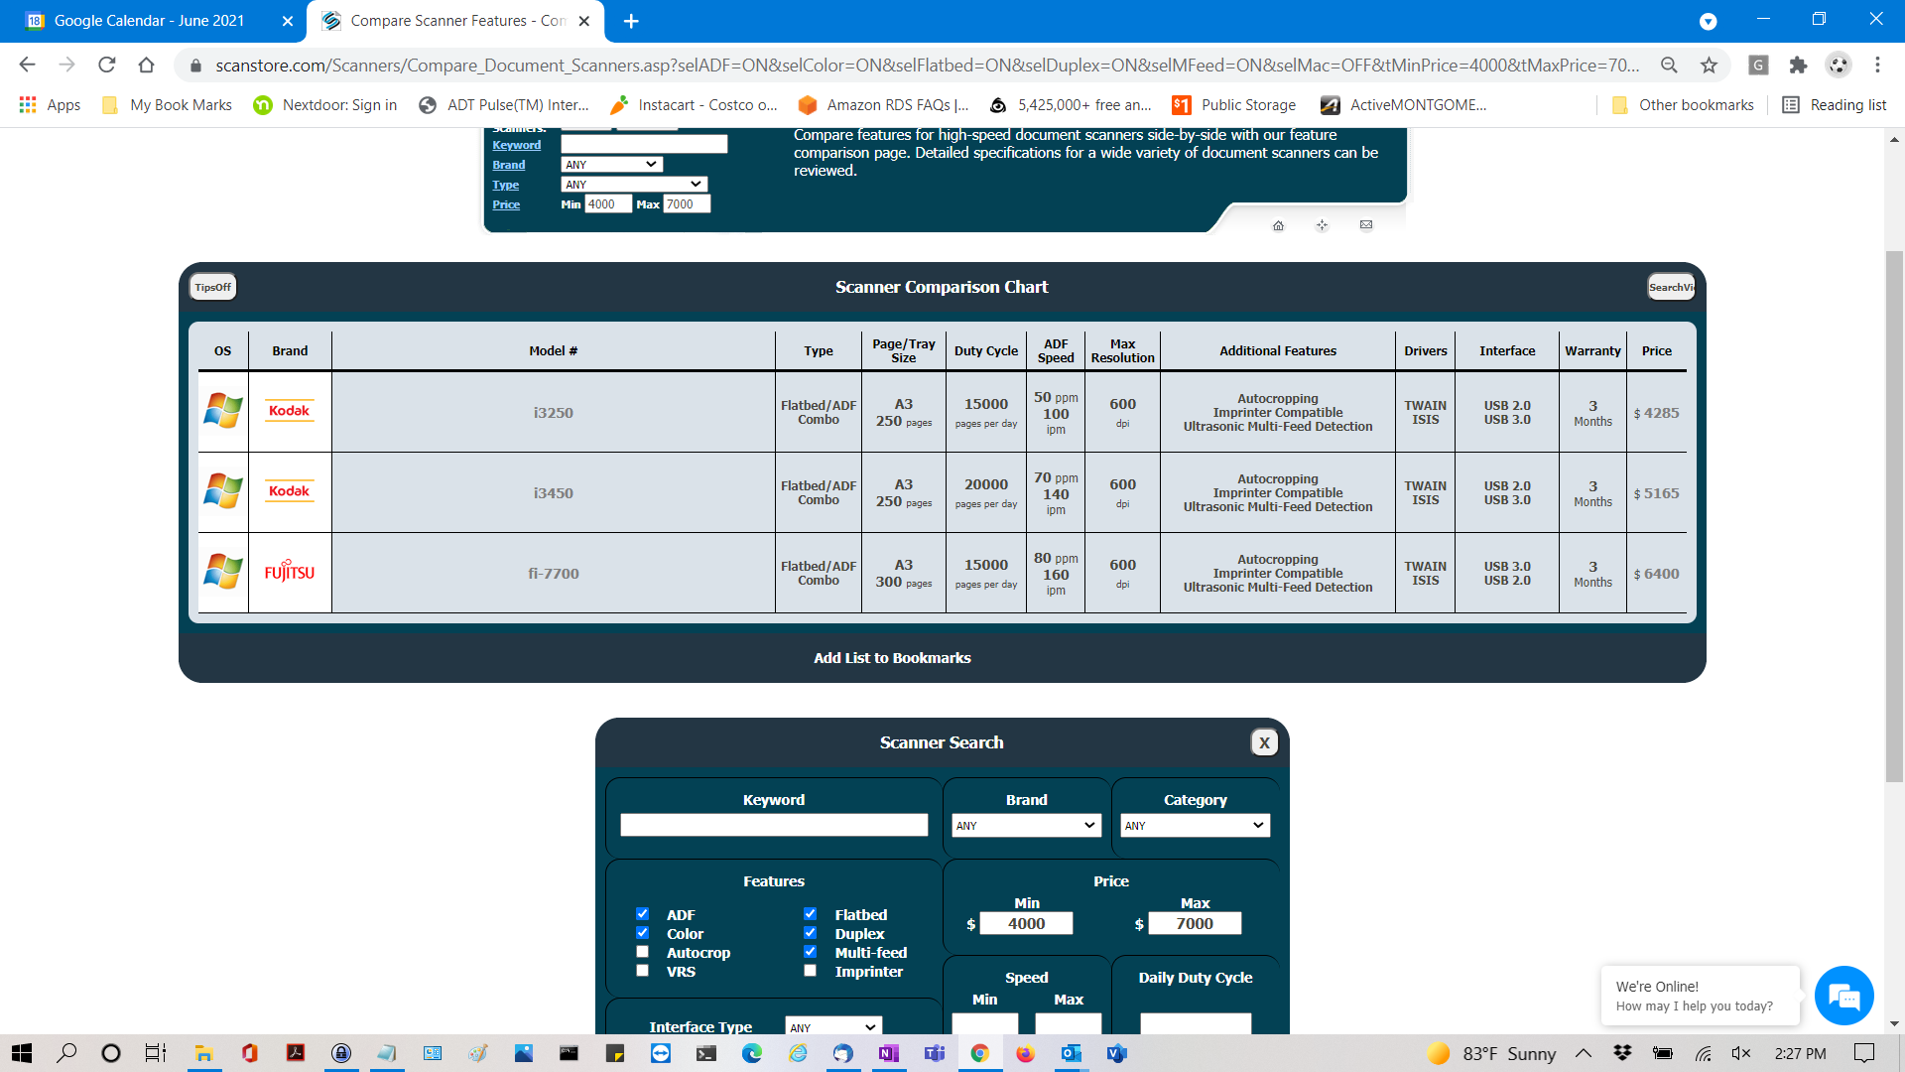

2 -

Epson

https://www.scanstore.com/Scanners/Compare_Document_Scanners.asp?selInterface=0&selMac=OFF&selMan=

EN&selItemType=7&tMinPrice=3000&tMaxPrice=5000&tScansPerDay=&ShowSearch=Yes

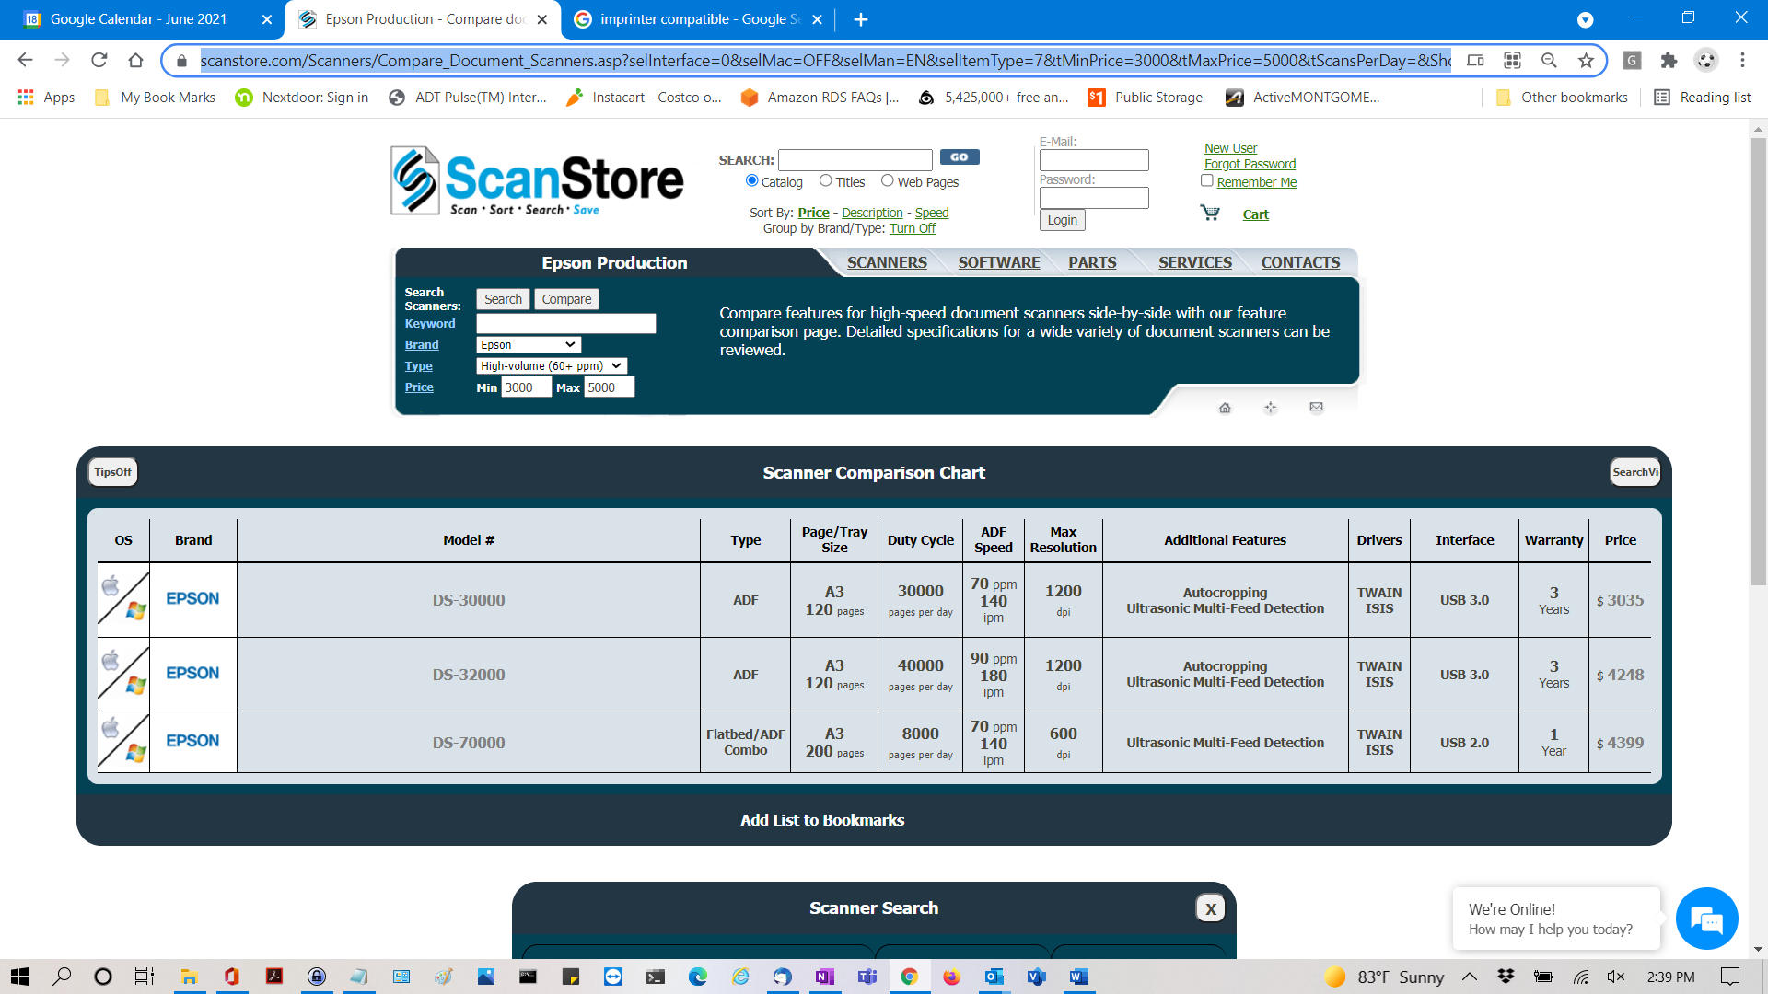

3 –

Kodak & Xerox

https://www.scanstore.com/Scanners/compare_document_scanners.asp?ITEM_ID=

23632&LastURL=https%3A%2F%2Fwww%2Escanstore%2Ecom%2FScanners%2Fdefault%2Easp%3FbUpdate%3D0%26Keyword%3D%26selMan%3DKD%26selItemType%3D7%26tMinPrice%3D4000%26tMaxPrice%3D6000%26

